**Project Design Phase-II**

**Technology Stack (Architecture & Stack)**

|  |  |
| --- | --- |
| Date | 03 October 2022 |
| Team ID | PNT2022TMID19672 |
| Project Name | Project – Personal Expense Tracker |
| Maximum Marks | 4 Marks |

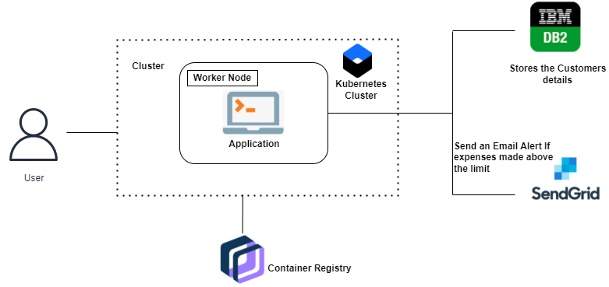

**Table-1 : Components & Technologies:**

|  |  |  |  |
| --- | --- | --- | --- |
| **S.No** | **Component** | **Description** | **Technology** |
|  | User Interface | The user can interact with the application | HTML, CSS, JavaScript |
|  | Application Logic-1 | The application contain the signin/signup and also login details | Java / Python |
|  | Application Logic-2 | The income and the expenses can be shown in the dashboard | IBM Watson STT service |
|  | Application Logic-3 | The expense report will be sent to the user | IBM Watson Assistant |
|  | Database | The income and expense will be stored in database. | MySQL, NoSQL, etc. |
|  | Cloud Database | Database Service on Cloud will be in the secured manner | IBM DB2, IBM Cloudant etc. |
|  | File Storage | File storage requirements are used to store the financial data of the user | IBM Block Storage or Other Storage Service or Local Filesystem |

**Table-2: Application Characteristics:**

| **S.No** | **Characteristics** | **Description** | **Technology** |
| --- | --- | --- | --- |
|  | Open-Source Frameworks | Flask-Framework in python is used to implement | Python-Flask |
|  | Security Implementations | It provides the high security to the user | Kubernetes Cluster |
|  | Scalable Architecture | The Personal Expense Tracker will increase the user income | Kubernetes Cluster |
|  | Availability | The user can use at any part of the time | Kubernetes Cluster |
|  | Performance | There will be high Performance and no bugs | Kubernetes Cluster |